Art Docent Poetry Project
March 2015

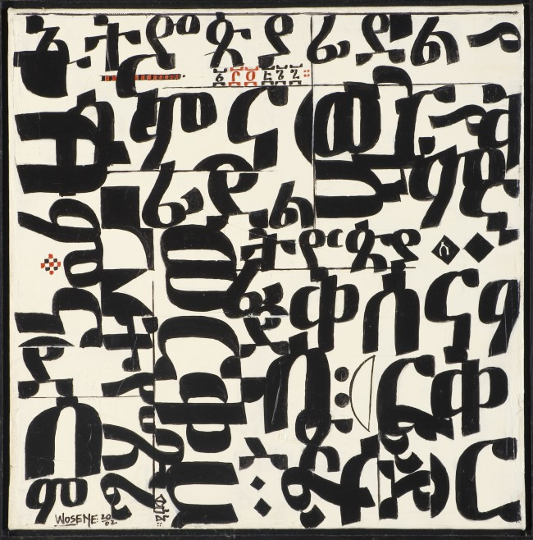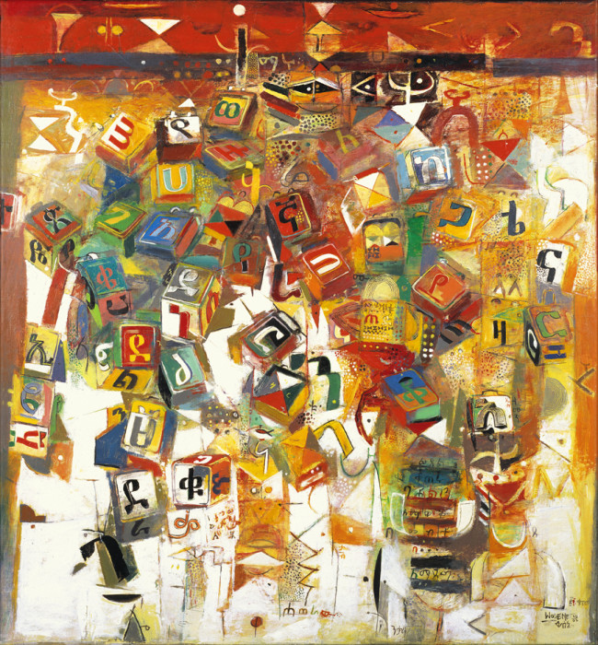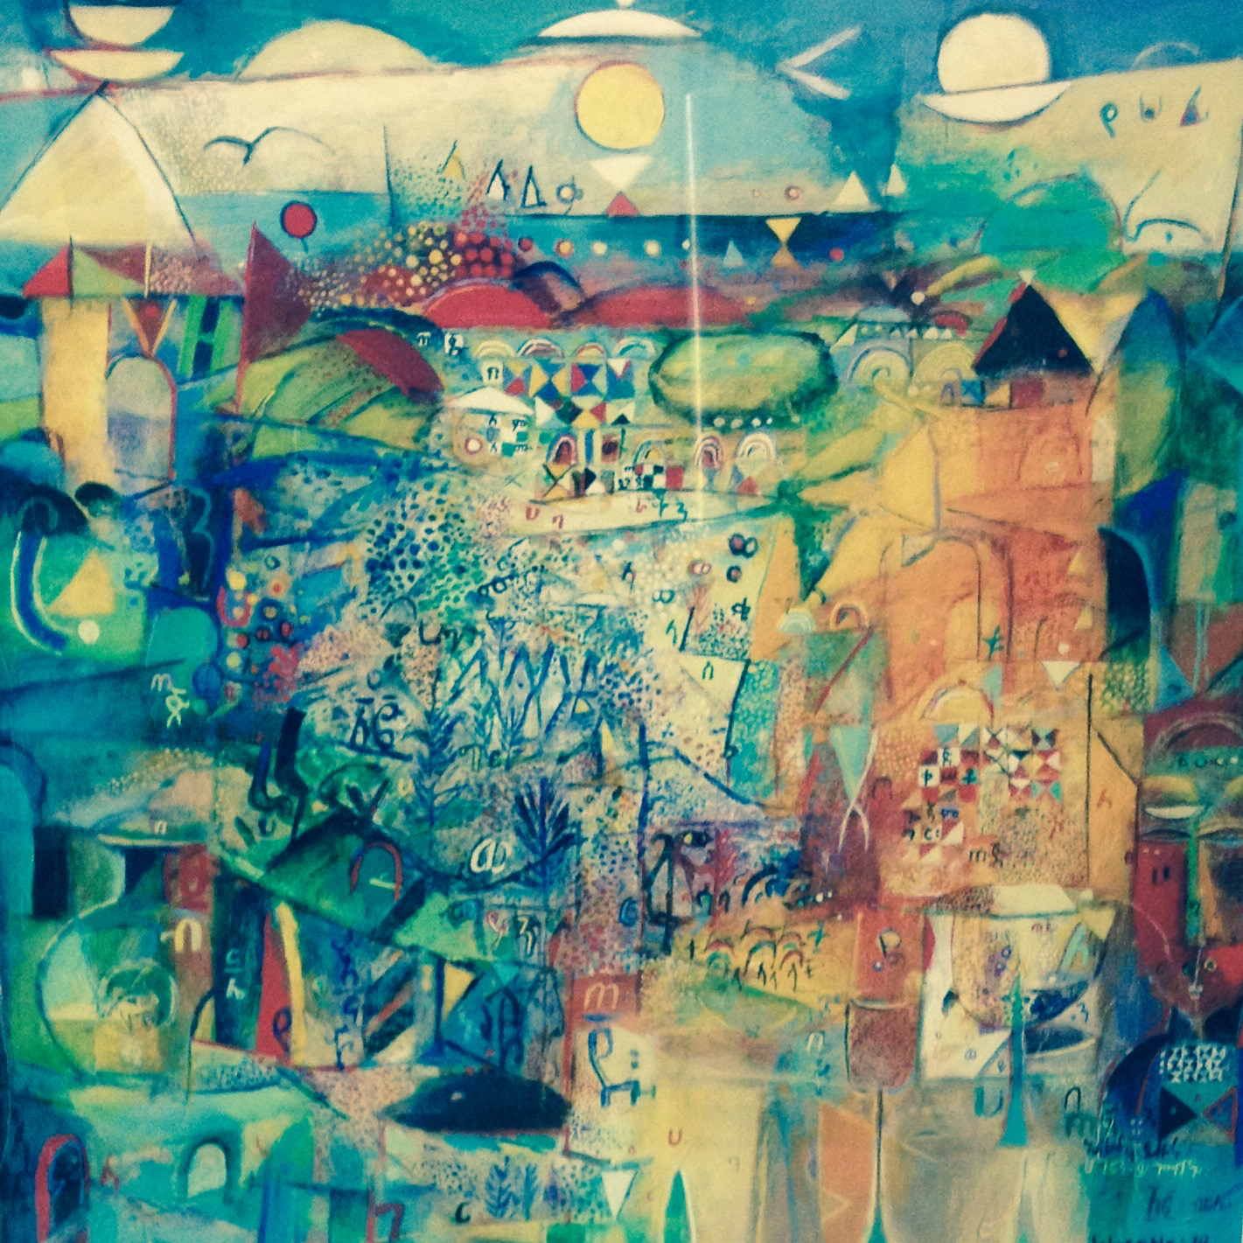
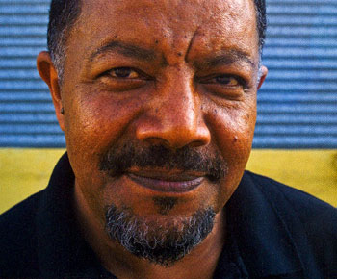 Color of Words

Artist: Wosene Worke Kosrof Painting: Scent of Spring

Wosene was born in 1950 in Addis Ababa (Capital City), Ethiopia and has achieved international acclaim. He is the first artist to use Amharic script – the Ethiopian alphabet – as a core element in his painting and sculptures. He doesn´t uses Amharic symbols as words – but as images that speak for themselves and American Jazz improvisation has also had a significant influence in his work. He compares his paintings to jazz and says that Jazz animates them with rhythmic movements and bold color.

“I elongate, distort, invert, and recombine shapes and turn them inside out to discover their moods, and personalities. On canvas, the script images are divested of their literal meanings to become gesture, dance, music, movement, and stories of the human drama.

“I create a visible, interactive surface—like visual icons that are accessible to everyone. My paintings invite viewers to dialogue with them, to take them into their memory.”

The process he uses is exploratory - he doesn´t pre-sketch and uses quick drying acrylics to easily build and change colors on canvas with a wide ranging palette- some black and white, some bold with many colors and some with just a touch of color.

Wosene’s works present us with a challenge to look into the art, feel its effect, and watch what happens.

Today, Wosene lives and has his studio in Berkeley, California.

Discussion:

•What is this a painting of? Scent of Spring is a departure from his technique of using Amharic letters.

•What do you see in this painting? What stands out to you?

•Do you see images that relate to the title “Scent of Spring?”

•What colors do you see?

•What shapes do you see? Anything recognizable? Are they elongated? distorted?

•How does this painting make you feel?

•Do you see movement in the painting?

-Does it tell a story? If it were a music or dance, how might it sound/look?

